Conagra Brands Report

BUAN 6337.003

Group 6

Tin Diep

Krishna Chaithanya Reddy Kapu Ramakrishna

Santhosh Sekar

Niral Devang Shah

Prasanth Chowdary Yanamandala

**Introduction**

The market for frozen meat substitutes is a billion-dollar industry in the United States, and Conagra Brands’ *Gardein* is among the top 5 leading brands. However, it is not enough to simply coast on current momentum to achieve the status of market share leader, regardless of how strong the momentum might be: competitors of all shapes and sizes will find new ways of seizing market share.

Thus, Conagra must take active measures to both guard and expand their market share. Such measures, if effective, require insight into the market to guide their usage. After all, resources earmarked for strategic use are of no use at all if they are spent wantonly.

The purpose of this report is to aid Conagra in allocating their resources into strategically meaningful ventures by deriving insights from nationwide point-of-sales data. The following sections all describe insight into a particular dimension of the provided data.

**Brand-level Market Triaging (See Appendix I for clearer plots):**

In analyzing the competitive landscape of frozen and refrigerated meat substitutes, we began with a market share analysis at the weekly level over the last four years. In doing so, we can ascertain the trend of brands relative to each other and determine who’s winning, who’s losing, who’s our closest competitor, and who we can put on the backburner.

FIGURE A: WEEKLY MARKET SHARE OF BRANDS

Combined with a linear trendline, we can see that there is a clear rising star in *Impossible*, with the steepest positive trendline among the major players. At a glance, it seems they are poised to eventually overtake *MorningStar Farms* as the market leader. It seems every player bar Conagra’s own *Gardein* is having their market share directly taken from them. On another note, the decline of the ‘Other’ brands indicates that the market is becoming increasingly concentrated.

However, knowing the competition is only half the battle: consider the weekly market share plot of Gardein in isolation.

FIGURE B: WEEKLY MARKET SHARE OF GARDEIN

Despite eking out the only other positive trend, we can see very large dips in weekly market share. Of interest is the apparently seasonal variation of market share; it seems Gardein sells the best in the winter season and worst in the summer season. The highlighted sections are approximately 3-month spans centered on July, which encapsulate the troughs in market share. Naturally, the next line of inquiry was the identity of the recipient of our summer market share.

We are most interested in large, easily observable swings that would bring the most relative improvement from addressing. As such, we exclude *Lightlife* from our inquiry due to their low market share and low level of fluctuation (see Figure A, brown line).

FIGURE C1: WEEKLY MARKET SHARE OF GARDEIN VS. MORNINGSTAR

A cursory analysis of the plot shows that *MorningStar* appears to also be subject to drops of market share in the summertime. Despite this indicating that *MorningStar* is not our opportunist, we should remember this similarity when it comes time to analyze the nature of our summertime weakness; there may be a common link.

FIGURE C2: WEEKLY MARKET SHARE OF GARDEIN VS. IMPOSSIBLE

*Impossible* appears to have some seasonal spike in the summertime, albeit only for the last two years of data. Coupled with their relatively recent status as a major player, (they broke through 1% market share at the beginning) it is a somewhat larger stretch to attribute the lost market share to them.

FIGURE C3: WEEKLY MARKET SHARE OF GARDEIN VS. BEYOND

*Beyond* seems to be our strongest single case as the summertime opportunist taking *Gardein’s* market share; they’ve consistently spiked every summer season.

Given the previous plots, it seems that *Beyond* is most culpable for our loss of market share. However, we are still left asking ‘why the summertime?’ We considered two perspectives: the physical season (temperature, weather, etc.) and the calendar (holidays, traditions, etc.)

Since the calendar is more generalizable, as the physical conditions vary considerably across the United States even during the same period of time, we investigated that perspective first. More specifically, the months of June and July in isolation.

FIGURE D1: MARKET SHARES OF GARDEIN IN THE SUMMER

Isolating out both *Gardein* and the summer weeks, we can see that there is a consistent two whole percent market share swing on the very first end-of-week in July (the 5th datapoint in every sequence).

FIGURE D2: MARKET SHARES OF GARDEIN, IMPOSSIBLE, AND BEYOND IN THE SUMMER

With red highlights indicating that the 5th week of the sequence is also consistently a peak of *Beyond* and trough of *Gardein*, we are more convinced of the relationship. Contrast *Impossible*, which has much more normal variation in their summer market share.

It is our hypothesis that these large shifts in market share coinciding with the first end-of-week occurring in July, are due to Independence Day celebrations on the 4th of July. Particularly, it is a common tradition for Americans to have a social gathering centered around a cookout or barbeque. In other words, meat is centrally important, and thus, substitutes for meat as well. Following this line of reasoning indirectly validates the ‘physical season’ perspective as well in that cookouts and barbeques are usually constrained and associated with stable and warm weather; summertime weather.

Unfortunately, we do not have any 4th of July specific data in regard to any brand attempts to capitalize on the celebration. However, we could compare the level of brand promotions for the weeks surrounding the holiday.

FIGURE E1: AVERAGE PRICE DROP FROM PROMOTION BY WEEK FOR GARDEIN AND BEYOND, JUNE AND JULY

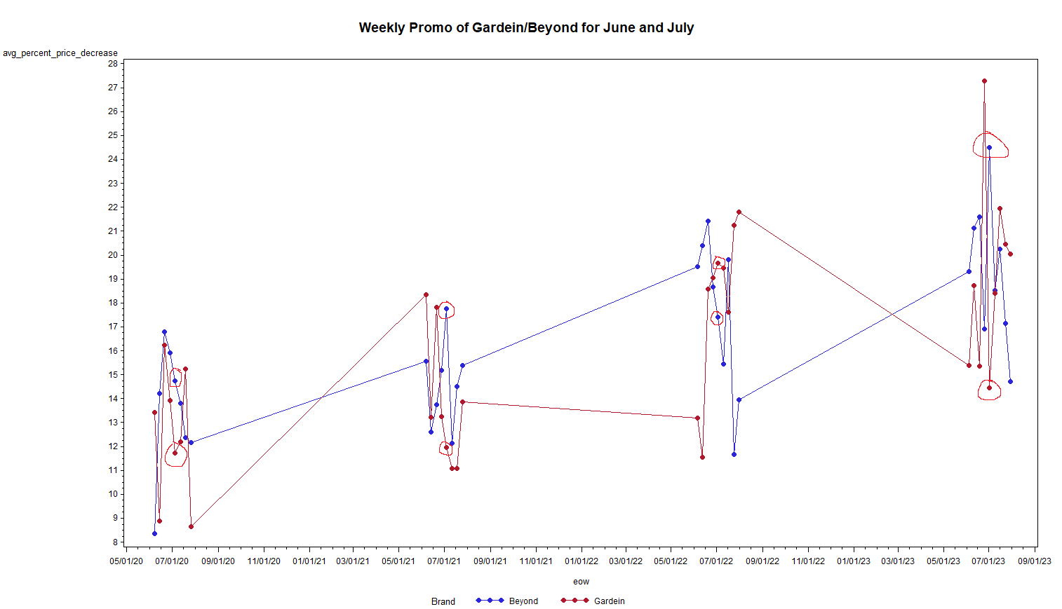

For each summer sequence, we’ve circled the 5th weeks in red. Notably, each 5th week has *Beyond* ramp up the average discount of their promoted goods. Contrast *Gardein* doing the opposite of that, lowering the average discount of their promoted goods. We note there is an exception to this in 2022.

With the information gathered so far, the conclusion we have reached regarding our analysis of brand market shares is that *Beyond* has seasonally taken meat substitute market share from *Gardein* using heavy promotion on the first end-of-week of July, targeting US Independence Day celebrations. However, we have yet to obtain robust data that validates this hypothesis on causal grounds. Further analysis would include examining regional market shares as well, not just on the national level. Additional data that concretely connects market share data to specific promotional campaigns (such as those centered around Independence Day) would also aid in validating or weakening our conclusion.

**Product Attributes with the Greatest Opportunity for CAG:**

From the detailed view of the top-performing attributes, we can infer several insights regarding the forms, flavors, and packaging that present the greatest opportunities for Conagra Brands (CAG) in the meat alternatives market.

1. **Form:**
   * **Burger Patties and Nuggets** are among the forms with the highest dollar sales, indicating strong consumer demand for these products.
   * **Specialized Breakfast Items** like breakfast patties and links also show high sales, suggesting a market opportunity in breakfast meat alternatives.
   * **Ground** and **Sausage Links** are traditional meat forms that have been successfully transferred to the meat alternative category, reflecting consumer desire for familiar formats.
2. **Flavor:**
   * **Regular and Original** flavors are consistent top performers, which might suggest that consumers prefer traditional flavors that mimic the taste of real meat.
   * **Specialty Flavors** such as Spicy Black Bean and Hickory Smoked show significant sales, pointing to a market segment interested in diverse and robust flavor profiles.
   * **Maple and Apple** flavors in breakfast items show success, indicating an opportunity for flavor innovation in breakfast meat alternatives.
3. **Package:**
   * **Resealable Plastic Bags** and **Boxes** dominate the packaging types, which may be due to convenience and sustainability factors appreciated by consumers.
   * **Vacuum Packed** products are also high in sales, implying a consumer preference for freshness and possibly an association with quality.

Based on these observations, CAG might consider the following strategic opportunities:

* Focus on expanding their range of burger patties and nuggets, possibly introducing more flavors within these forms.
* Explore the breakfast segment further, capitalizing on the success of breakfast sausages and patties by potentially introducing new breakfast-specific flavors.
* Maintain the offering of products with regular and original flavors, ensuring these are available in various forms to cater to consumer demand for traditional tastes.
* Experiment with new flavor profiles in high-performing forms to capture consumers interested in variety, without moving away from successful traditional flavors.
* Evaluate the packaging strategies, potentially introducing more products in resealable and vacuum-packed options to align with consumer preferences for convenience and freshness.

By leveraging the data from top-performing product attributes, CAG can tailor their product development and marketing strategies to match consumer preferences, capitalize on current successes, and explore new opportunities within the Meat Alternatives category.

While Gardein does not appear as frequently as Beyond Meat and Impossible Foods in the top sales lists across multiple regions, there are notable entries in the South Central and Southeast regions. This suggests that there are strongholds where Gardein has significant market penetration or a dedicated consumer base.

In the South-Central region, the Gardein product ranks well, with significant dollar sales of approximately $2.49 million in 2020. This performance can be highlighted as a key achievement in the region and used in marketing strategies to enhance brand recognition and loyalty.The Southeast region also shows potential, with sales substantial enough to place it in the top 10 products for 2020.

While Beyond Meat and Impossible Foods dominate top spots, there is a clear opportunity for Gardein to capitalize on specific niches that these competitors may not fully address, such as the frozen sector or specific types of meat substitutes like ground meat. Expanding the presence in regions where Gardein products are already performing well can be achieved through targeted marketing campaigns, enhanced distribution strategies, and partnerships with local retailers.

**The Effect of Merchandising on Unit Sales Across Regions:**

Looking at the market share,

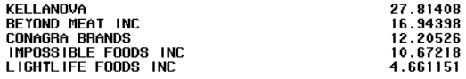

We can see that ‘Kellanova’ of MorningStar and ‘Beyond Meat Inc’ of Beyond are the two brands holding higher market share than ‘Gardein’ of Conagra. Let's look at the effects of merchandising in each region of the US for these 3 brands:

The maps show the region name and their color-coded area along with the unit sales difference with respect to California’s under merchandising.

**All Brands:**

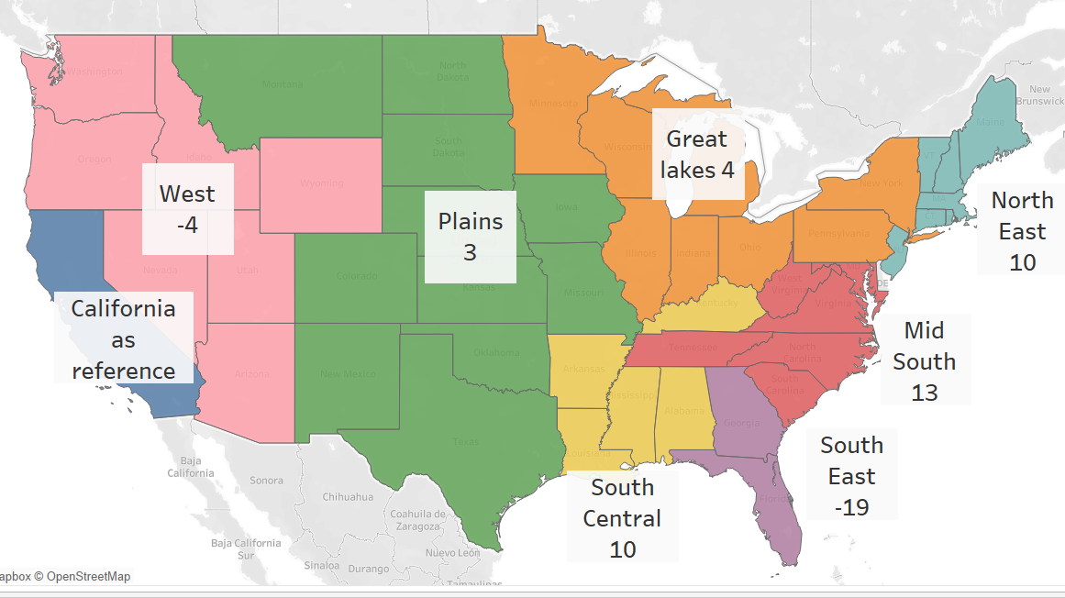

The least popular regions in the US are the West and Southeast when looked at considering all brands and their meat substitute products.

**Beyond:**

Beyond’s meat substitutes perform way better in the least popular regions. When compared with the overall map, other brands are severely lacking in these regions.

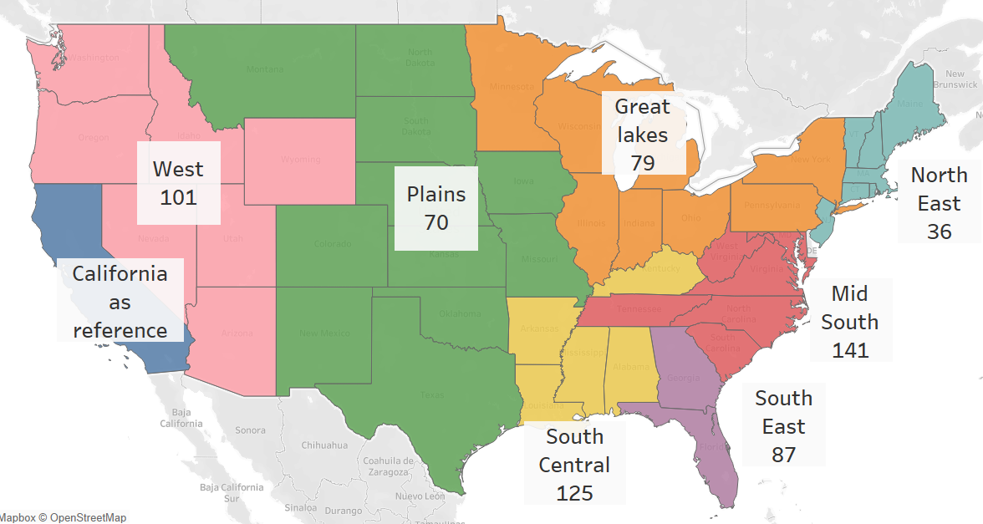

**MorningStar:**

MorningStar performs the best at West and South Central but drops way short to Beyond’s meat Substitutes.

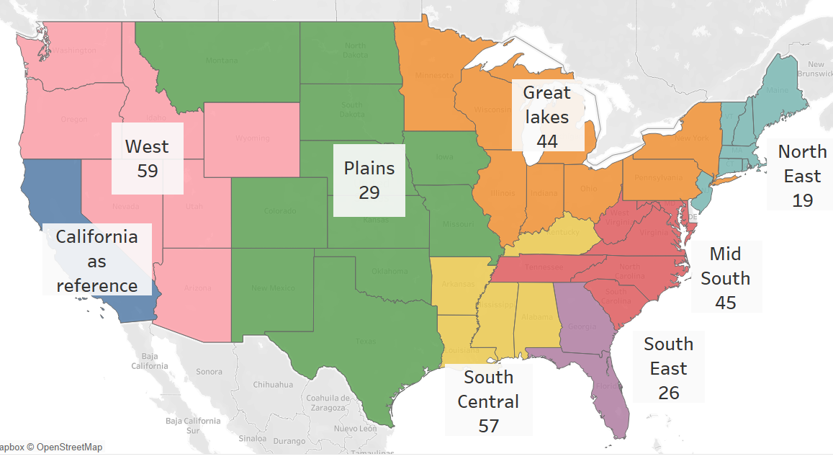

**Gardein:**

Gardein holding less than half of MorningStar’s market share, underperforms in most regions. There is a lot of scope for improvement in the West, Plains and Southeast where they are playing at the base level. Looking at the share of Beyond’s merchandise market in these regions gives a lot of room for Gardein to make an impact.

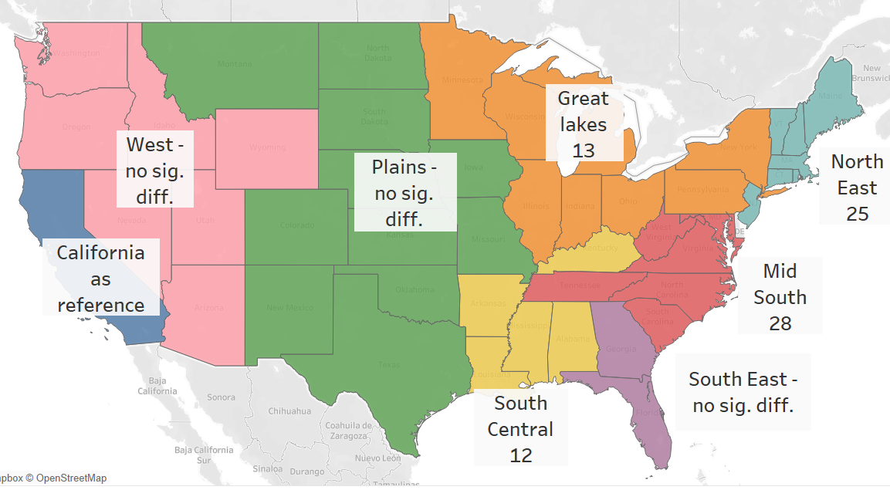

In these regions ‘Gardein’ can introduce products like:

* GARDEIN FROZEN REGULAR MEAT SUBSTITUTE GROUND 13.7 OZ
* GARDEIN FROZEN CHICKEN PLANT BASED CHICKEN SUBSTITUTE WING 14.8 OZ
* GARDEIN FROZEN TERIYAKI POULTRY SUBSTITUTE STRIP 10.5 OZ
* GARDEIN FROZEN REGULAR POULTRY SUBSTITUTE WING 8.4 OZ
* GARDEIN FROZEN REGULAR MEAT SUBSTITUTE BURGER PATTY 40 OZ

These products perform better than others in ‘Gardein’ as they have the highest $ sales margin under merchandising.

The lack of performance in these regions might be due to the difference in taste of demographics of the region.

**Spicy** substitutes tend to attract a lot more customers as ‘Beyond’ and ‘Morningstar’ have meat substitutes in the section which are performing at the top but missing in ‘Gardein’. They can add features to their spicy substitutes to infiltrate the market in those regions.

APPENDIX

APPENDIX I:

FIGURE A: WEEKLY MARKET SHARE OF BRANDS

FIGURE B: WEEKLY MARKET SHARE OF GARDEIN

FIGURE C1: WEEKLY MARKET SHARE OF GARDEIN VS. MORNINGSTAR

FIGURE C2: WEEKLY MARKET SHARE OF GARDEIN VS. IMPOSSIBLE

FIGURE C3: WEEKLY MARKET SHARE OF GARDEIN VS. BEYOND

FIGURE D1: MARKET SHARES OF GARDEIN IN THE SUMMER

FIGURE D2: MARKET SHARES OF GARDEIN, IMPOSSIBLE, AND BEYOND IN THE SUMMER

FIGURE E1: AVERAGE PRICE DROP FROM PROMOTION BY WEEK FOR GARDEIN AND BEYOND, JUNE AND JULY



